**Task 1: Create an application named DebugConsole having the following UI**

**xml:**

<?xml version="1.0" encoding="utf-8"?>  
<LinearLayout xmlns:android="http://schemas.android.com/apk/res/android"  
 xmlns:app="http://schemas.android.com/apk/res-auto"  
 xmlns:tools="http://schemas.android.com/tools"  
 android:layout_width="match_parent"  
 android:layout_height="match_parent"  
 android:orientation="vertical"  
 tools:context="com.example.android.broadcast2.MainActivity">  
  
  
 <LinearLayout  
 android:layout_width="wrap_content"  
 android:layout_height="wrap_content">  
 <EditText  
 android:id="@+id/num1"  
 android:layout_width="wrap_content"  
 android:layout_height="wrap_content"/>  
  
 <TextView  
 android:layout_width="wrap_content"  
 android:layout_height="wrap_content"  
 android:text="/" />  
 <EditText  
 android:id="@+id/num2"  
 android:layout_width="wrap_content"  
 android:layout_height="wrap_content"/>  
 <Button  
 android:id="@+id/btn_div"  
 android:layout_width="wrap_content"  
 android:layout_height="wrap_content"  
 android:text="Send"  
 android:onClick="onBtnSend" />  
  
 <TextView  
 android:id="@+id/answer"  
 android:layout_width="wrap_content"  
 android:layout_height="wrap_content"  
 android:text="" />  
 </LinearLayout>  
  
 <TextView  
 android:id="@+id/logTxt"  
 android:layout_width="match_parent"  
 android:layout_height="310dp"  
 android:layout_marginTop="100dp"  
 android:background="@color/bg"  
 android:textColor="@color/text"  
 android:textSize="20sp"  
 android:lines="15"  
 android:scrollbars="vertical" />  
  
</LinearLayout>

**JAVA:**

package com.example.android.broadcast2;  
import android.content.Intent;  
import android.support.v7.app.AppCompatActivity;  
import android.os.Bundle;  
import android.util.Log;  
import android.view.View;  
import android.widget.EditText;  
import android.widget.TextView;  
  
import java.time.LocalDateTime;  
import java.util.Date;  
  
public class MainActivity extends AppCompatActivity {  
  
 Intent intent;  
 TextView text,answers;  
 EditText text1, text2;  
 Integer a, b, ans;  
 @Override  
 protected void onCreate(Bundle savedInstanceState) {  
 super.onCreate(savedInstanceState);  
 setContentView(R.layout.activity_main);  
 text = (TextView) findViewById(R.id.logTxt);  
 answers = (TextView) findViewById(R.id.answer);  
 text1 = (EditText) findViewById(R.id.num1);  
 text2 = (EditText) findViewById(R.id.num2);  
 }  
 public void onBtnSend(View v) {  
 intent= new Intent();  
  
 a = Integer.parseInt(text1.getText().toString());  
 b = Integer.parseInt(text2.getText().toString());  
 try {  
 ans = a / b;  
 answers.setText(ans.toString());  
 }  
 catch (Exception e){  
 intent.putExtra("info",e.getMessage());  
 intent.setAction("DEBUG_INFO");  
 sendBroadcast(intent);  
 text.setText("Divide by zero");  
 }  
}  
}

color.xml:

<color name="bg">#1C9CCF</color>  
<color name="text">#000</color>

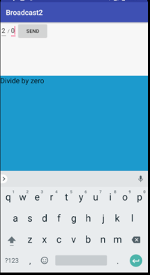

**Task 2: Create an application which can send broadcast to the DebugConsole (above application). You may use the following UI as reference.**

**XML:**

<?xml version="1.0" encoding="utf-8"?>  
<LinearLayout xmlns:android="http://schemas.android.com/apk/res/android"  
 xmlns:app="http://schemas.android.com/apk/res-auto"  
 xmlns:tools="http://schemas.android.com/tools"  
 android:layout_width="match_parent"  
 android:layout_height="match_parent"  
 android:orientation="vertical"  
 tools:context="com.example.android.broadcastreciever.MainActivity">  
  
 <EditText  
 android:id="@+id/debugMessage"  
 android:layout_width="match_parent"  
 android:layout_height="wrap_content"  
 android:inputType="textPersonName"  
 android:hint="Debug message goes here "  
 />  
 <Button  
 android:layout_width="match_parent"  
 android:layout_height="wrap_content"  
 android:onClick="onBtnSend"  
 android:text="Send"  
 tools:layout_editor_absoluteX="16dp"  
 tools:layout_editor_absoluteY="73dp" />  
</LinearLayout>

**JAVA:**

package com.example.android.broadcastreciever;  
import android.content.BroadcastReceiver;  
import android.content.Context;  
import android.content.Intent;  
import android.content.IntentFilter;  
import android.support.v7.app.AppCompatActivity;  
import android.os.Bundle;  
import android.view.View;  
import android.widget.EditText;  
import android.widget.Toast;  
  
public class MainActivity extends AppCompatActivity {  
 EditText msg;  
 @Override  
 protected void onCreate(Bundle savedInstanceState) {  
 super.onCreate(savedInstanceState);  
 setContentView(R.layout.activity_main);  
 msg=(EditText) findViewById(R.id.debugMessage);  
 BroadcastReceiver br=new BroadcastReceiver() {  
 @Override  
 public void onReceive(Context context, Intent intent) {  
 String s=intent.getStringExtra("info");  
 Toast.makeText(getApplicationContext(), s, Toast.LENGTH_SHORT).show();  
 }  
 };  
 IntentFilter filter =new IntentFilter("DEBUG_INFO");  
 registerReceiver(br,filter);  
  
 }  
  
 public void onBtnSend(View v) {  
 Intent intent = new Intent();  
 intent.putExtra("info", msg.getText().toString());  
 intent.setAction("DEBUG_INFO");  
 sendBroadcast(intent);  
 Toast.makeText(getApplicationContext(),"sent",Toast.LENGTH_LONG).show();  
 }  
}

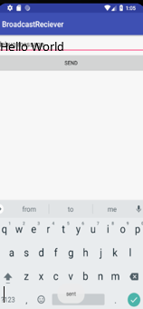

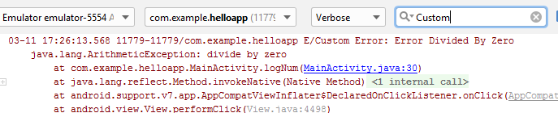

Hello World